User Manual for Graphical User Interface (GUI) LFArk1.exe for Estimating Low-Flow Characteristics at Ungaged Basins in Arkansas

- List of required files:
- MCRInstaller.exe
- LFArk1.exe
- LFArk1.ctf
- Installation instructions for MCRInstaller.exe:
Before beginning the installation on your computer, verify that you have full administration privileges on the computer. Set the permissions on this folder to read and write access. The purpose of MCRInstaller.exe is to allow a computer to use stand-alone Matlab executables, such as LFArk1.exe, without having a license from Mathworks, Inc.

To begin installation, go to Windows Explorer and find the folder containing the program MCRInstaller.exe. Double click on this folder to launch the application. The following screen will appear on your desktop environment:
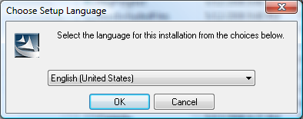
Select language and press the “OK” button. A window opens next showing the status of the program preparing to install.
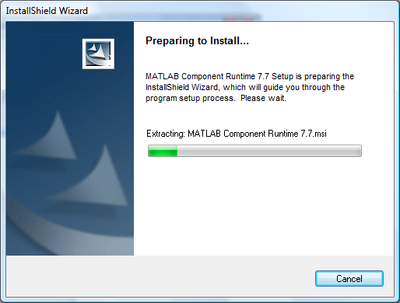
The following window opens:
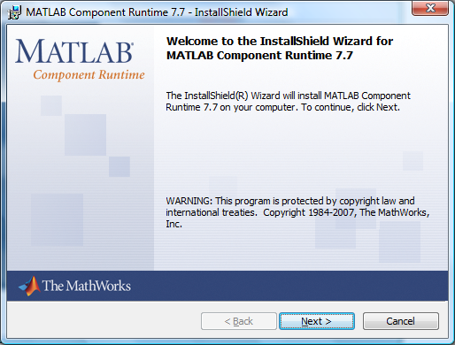
Click the “Next >” button to continue and the following window opens:
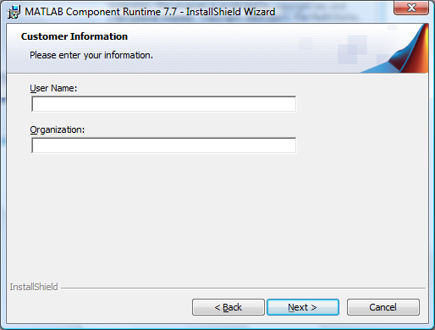
After entering the “User Name” and “Organization” information, click on the “Next >” button. You will be prompted for a directory to install the program in the following window:
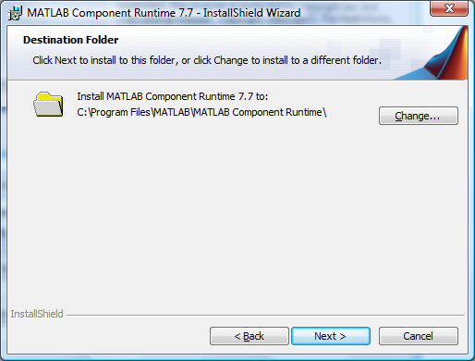
It is strongly suggested to install the files in the default location indicated in the window. It should begin with “c:\Program Files\MATLAB\MATLAB Component Runtime\…” . Click the “Next >” button to begin the installation, and you should see the following window:
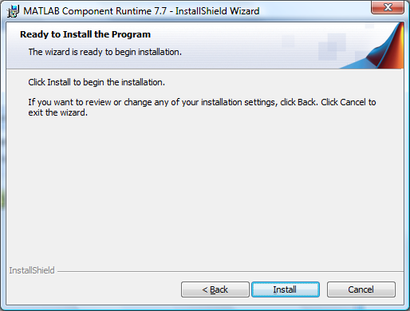
Click on the “Install” button to begin installation. During installation, the status will be displayed in the following window:
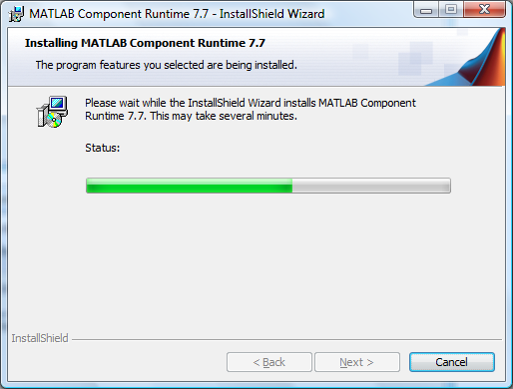
When the installation is complete, you will see the following window:
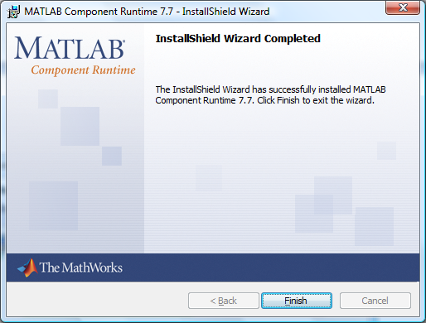

- Running the Low-Flow Characteristics Program LFArk1.exe:
To run the stand-alone executable program LFArk1.exe, please go to Windows Explorer and locate LFArk1.exe program on your computer (not on the CD) and double-click the program. The following window will appear:
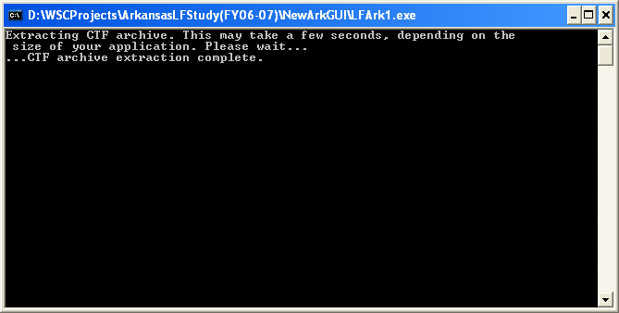
Note: If a “Warning:…” message appears in this window, please ignore because the program is looking for a toolbox that the program does not use. After this step, in the same directory of the stand-alone executable program, a folder called LFArk1_mcr will be created. Do not open, change, or move any files in the .ctf folder that accompanies the stand-alone executable program. This file and a resulting folder “LFArk1_mcr” must remain in the same directory as LFArk1.exe.

After several moments (30 seconds – 2 minutes), the main graphical user interface (GUI) program window will open for the Low-Flow Characteristics Estimation program for Arkansas (hereafter referred to as the main GUI interface) and should look like the following:

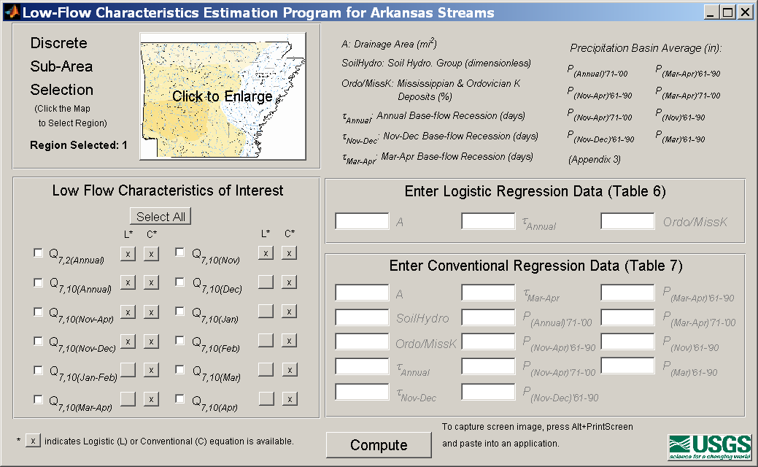

Note that all GUI interfaces are resizable, so just place the cursor over any corner of a GUI interface and click and drag to desired size.
- Computation of Low-Flow Characteristics using LFArk1.exe:
  - Region Selection
Go to the upper left of the main GUI interface (shown below) and click on the miniature map to enlarge it (the default region is 1).
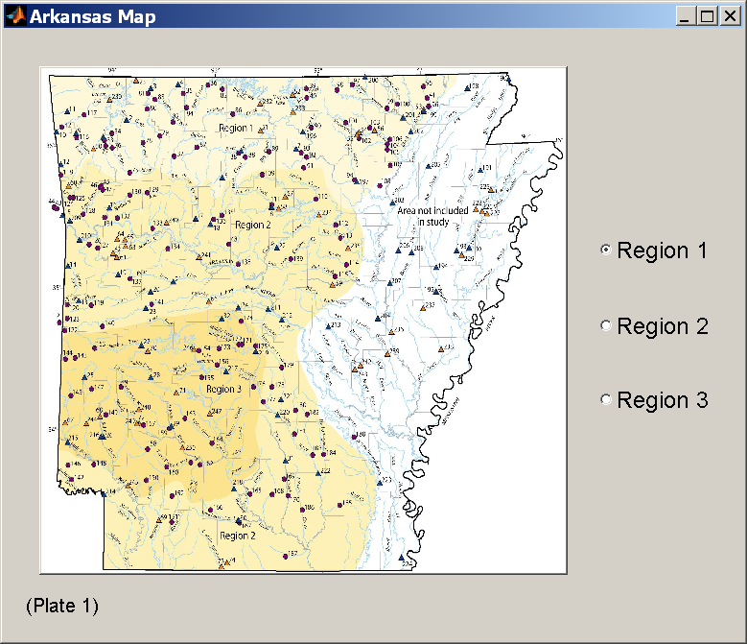
Enlarged version of miniature map

To select a region, toggle the corresponding radio button on the right side of the “Arkansas Map” window and an enlarged map will open. For example, if region 1 is selected the following window opens:
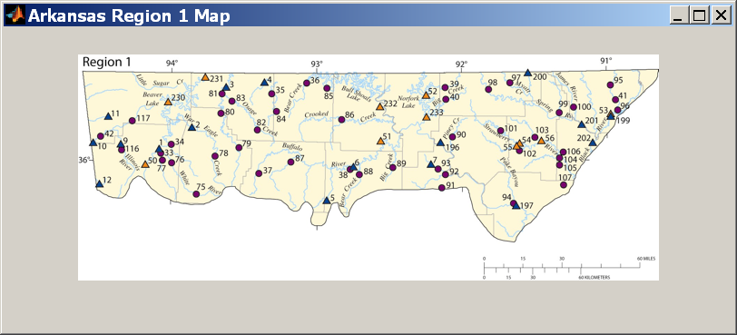

  - Low-flow characteristic selection
Click the box adjacent to the “Low-Flow Characteristics of Interest” in the lower left box of the main GUI interface (shown on following example of the main GUI interface). The “Select All” can be used if the user desires all the characteristics, and the same button can be used to clear all the selected entries. Please note that an “x” in the “L” and “C” columns indicates that a logistic regression is available, and a conventional weighted least squares (hereafter referred to as conventional) regression is available, respectively.

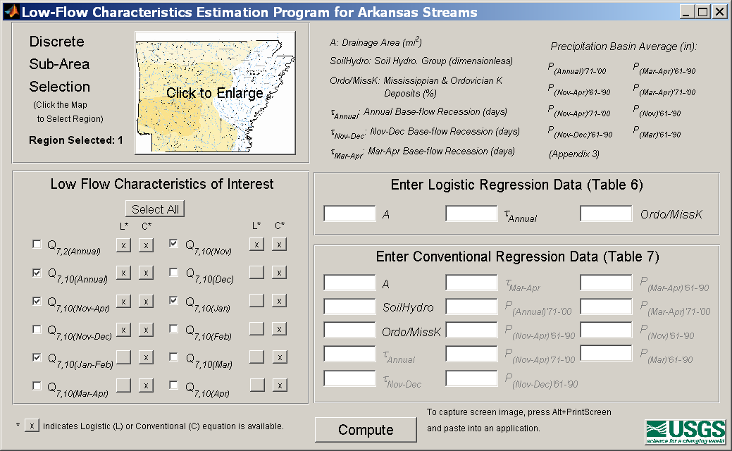
  - Entering basin characteristic values
The upper right box of the main GUI interface lists all the variables used (and associated units) in the logistic and conventional regression models. Enter the numerical data into the active boxes in the lower right corner of the following interface called “Enter Logistic Regression Data (Table 6)” and “Enter Conventional Regression Data (Table 7).” Black text in the preceding GUI interface example indicates active boxes which require values for the selected regression models. The following example of the main GUI interface shows values entered in the active boxes.
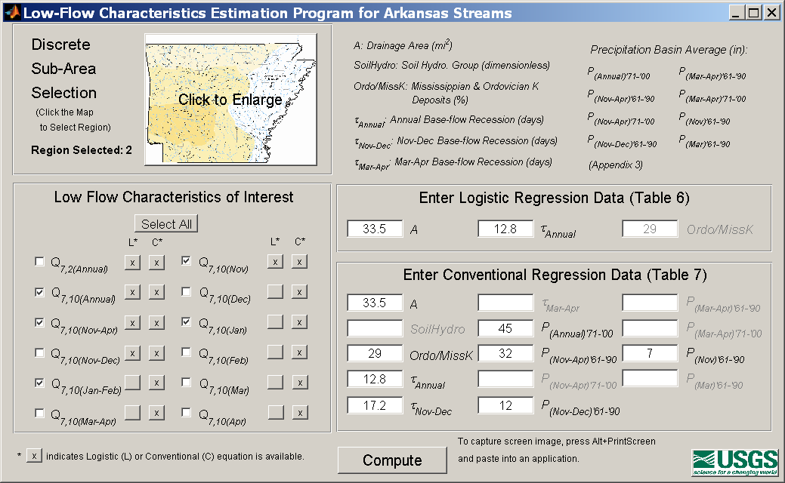
Enter only numerical data into the boxes or the following error message will occur:
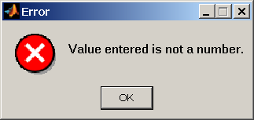
Click “OK” and the Error box will be deleted.

  - Computation of low-flow characteristics
Click the “Compute” button on the bottom of the main GUI interface to compute the low-flow characteristics. Estimates of the low-flow characteristics are reported on the main GUI interface for “Results: Estimates of Low-flow Characteristics at Ungaged Basins” (Results GUI interface) that will open automatically.
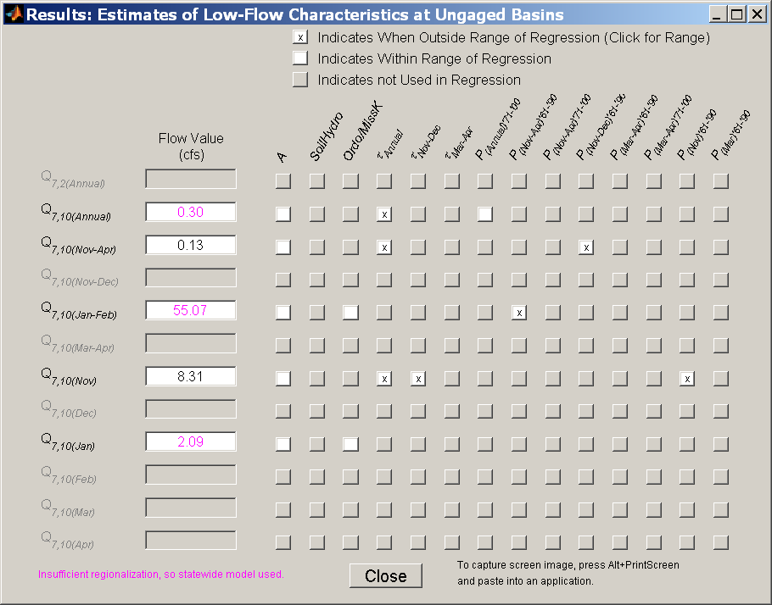
The selected low-flow characteristics are displayed on the left side of the Results GUI interface and the estimated flow values in cubic feet per second (cfs) are displayed in the box. Purple fonts are used for regression models (logistic or conventional regression model) that are statewide models (tables 6 and 7), while black fonts are used for the models associated with the three regions in Arkansas (tables 6 and 7). For each low-flow characteristic of interest there are fourteen boxes displayed indicating when extrapolation problems exist for the entered basin characteristic values. A grayed box indicates that the basin characteristic was not used in either logistic or conventional regression models. An empty white box indicates that a basin characteristic was used in either logistic or conventional regression models, and that there is no problem of extrapolation based on the entered value. An ‘x’ mark in a white box indicates that the entered basin characteristic is outside the range that was used to develop either the logistic or conventional regression models. Clicking on these ‘x’ boxes opens a window such as the following:
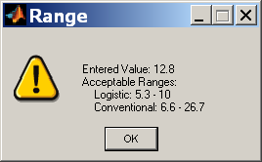
This interface displays the entered value and the acceptable ranges of the logistic and conventional regression models.

  - Saving images of GUI interfaces
To create image files of any GUI interface, the user can click onto the desired GUI interface and press “Alt+Print Screen” buttons on their keyboard. Then, open a program (such as Microsoft Word, Excel, Paint) and paste the image.

  - Output text files of LFArk1.exe
In addition to the producing images of the GUI interfaces, two text tab-delimited output files are created. Programs such as WordPad or any other program that can display text tab-delimited files can open them. One output file (LogisticRegrSummary.txt) reports the results of the logistic regression models, and the other file (WLSRegrSummary.txt) reports the results of the conventional regression model. A screen capture of the LogisticRegrSummary.txt file is shown here:
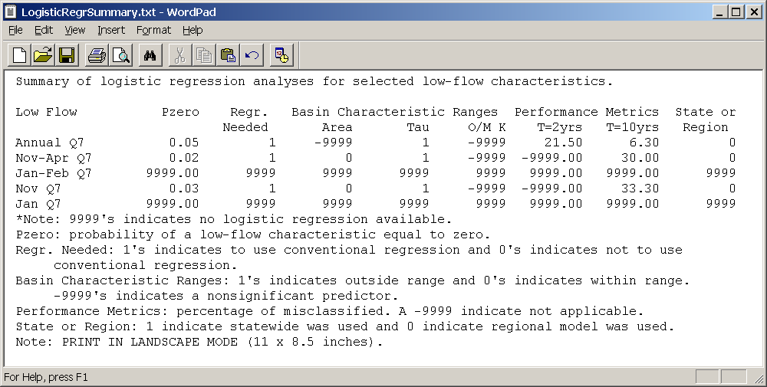
The “Low Flow’ column lists the low-flow characteristic chosen by the user, and the “Pzero” column reports the probability of a low-flow characteristic being equal to zero. The values of “9999” indicate that no logistic regression model is available for the selected low-flow characteristics. A value of 1 in the “Regr. Needed” column indicates when the Pzero value is less than 1/T (where T is the return period of interest), so a conventional regression model is needed in this example. The columns under the “Basin Characteristic Ranges” heading report when a basin characteristic value that the user entered is outside the range of values used to develop the equation. A “0” indicates that the entered value is within the range of values used to develop the equation, a “1” indicates that the entered value is outside the range, and a “–9999” indicates a non-significant basin characteristic. The “Performance Metrics” report the percent of basins misclassified by the equation in the preceding image, which measures the accuracy of the logistic regression models. The “State or Region” column reports whether a statewide logistic regression model or a regional regression model was used. Please note that the printed version of the .txt file must use landscape mode (as noted at the bottom of the LogisticRegrSummary.txt file).

A screen capture of a WLSRegrSummary.txt file is shown here:
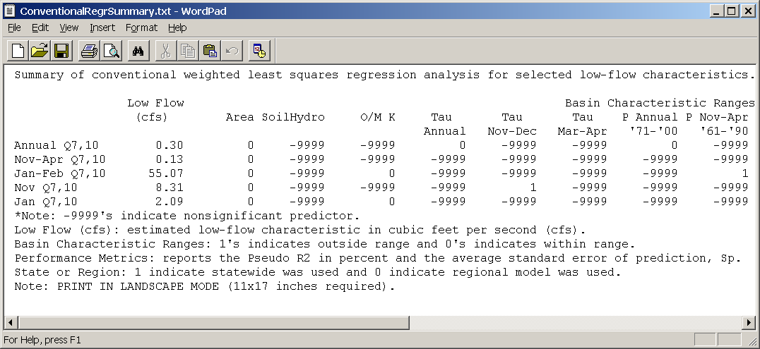
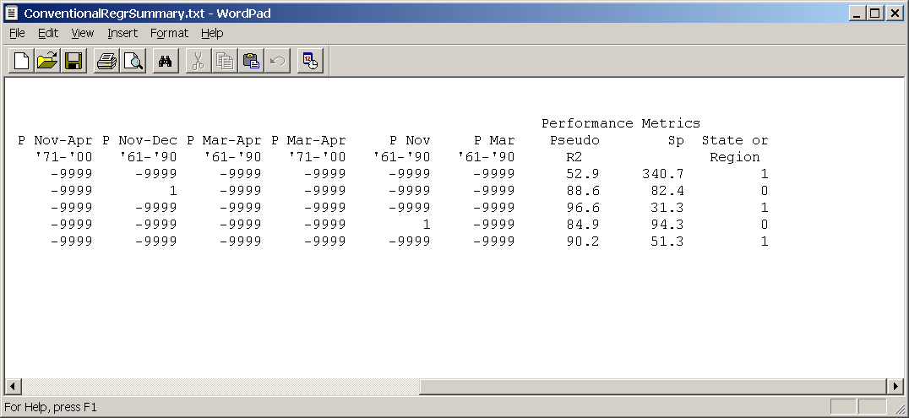

The “Low Flow (cfs)” column lists the estimated low-flow characteristic values in cubic feet per second. The 14 columns under the “Basin Characteristic Ranges” report when a basin characteristic value that the user entered is outside the range of values used to develop the equation. A “0” indicates that the entered value is within the range of values used to develop the equation, a “1” indicates that the entered value is outside the range, and a “–9999” indicates a non-significant basin characteristic. The “Performance Metrics” report the amount of variability explained (pseudo R²) by the conventional regression model in percent and the average standard error of prediction (S_{p}) in percent of the model. The “State or Region” column reports whether a statewide conventional regression model or a regional one was used. Please note that to view the entire 14 columns, the user must print the file in landscape mode using 11 × 17 paper (as noted at the bottom of the WLSRegrSummary.txt file).

