The U.S. Geological Survey (USGS) Upper Colorado River Basin Streamgage and Watershed Analysis Tool (UCRB SWAT) allows for analysis and query of watershed characteristics in the Upper Colorado River Basin (UCRB). The tool is a companion to USGS Scientific Investigations Report 2011-xxxx (Kenney and others, 2011) which presents the results of an analysis of the watersheds monitored by the USGS streamgage network in the UCRB. The tool allows the user to query or filter and compare watershed characteristics such as drainage basin size and land cover for the network of USGS streamgages, and for a set of 10,338 watersheds in the UCRB. Location information for both the streamgages and watershed outlets as well as the period(s) of record for the streamgages is also available.
Software requirements:
UCRB SWAT requires Microsoft Access to run. It was built using Microsoft Access 2010 and runs within both Access 2007 and Access 2010. The tool has not been tested using earlier versions of Microsoft Access.
Opening the streamgage and watershed analysis tool:
The user will be given a security warning when the UCRB SWAT tool is launched. The tool uses macros to run queries. Active content must be enabled for the queries to run. In Microsoft Access 2007, click the “Options” button and then click the “Enable this content” button in the resulting dialog box.
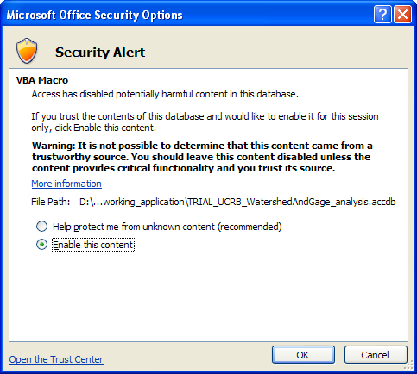

In Microsoft Access 2010, click the “Enable Content” button to allow the macros to run.

Choosing the query to run:
Four options are available to the user when UCRB SWAT is launched. The "Parameter information" button provides information about the types and measurement units of the parameters or watershed characteristics that are available to query. The “Help” button gives the user general information about the tool.
The remaining two options allow the user to query a database of the watersheds and streamgages in the UCRB by watershed characteristics, calculated for the contributing drainage area of each gage or watershed. A query is a way to filter information or answer questions about the data in a database. The button "Query streamgages" opens a form enabling the user to query 1,053 existing and historic UCRB streamgages. The button "Query watersheds" opens a form enabling input to query 10,338 watersheds in the UCRB.
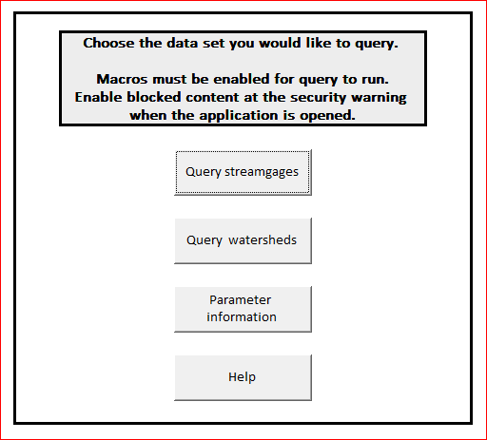
A form that allows the user to filter either streamgages or watersheds is launched when one of the query buttons is clicked. The minimum and maximum value for each parameter is automatically populated in the form when it launches. The user can change the values for one or more parameters to identify gages or watersheds that fall within the range of user input values.
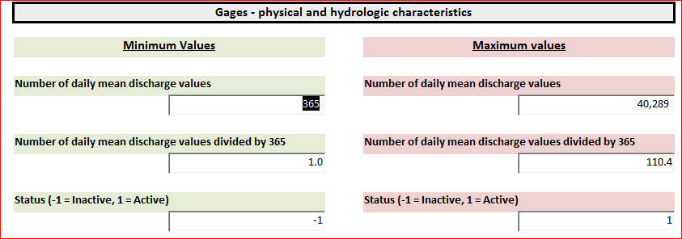
Once values are input, the query is run by clicking the “Run Query” button at the bottom of the input form. Additional help is available by clicking the “Help” button at the bottom of the form.
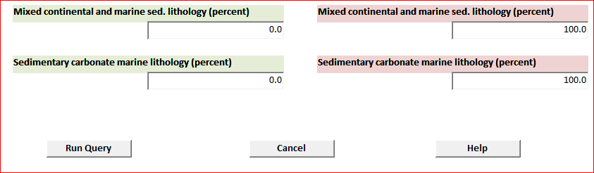

A table of results showing the gages or watersheds that fall within the range of the user’s input variables will appear when the query is run.
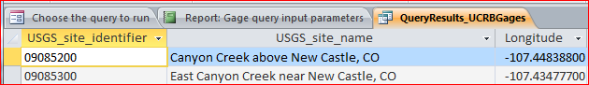

A report showing the inputs to the query will also be created when the query is run.
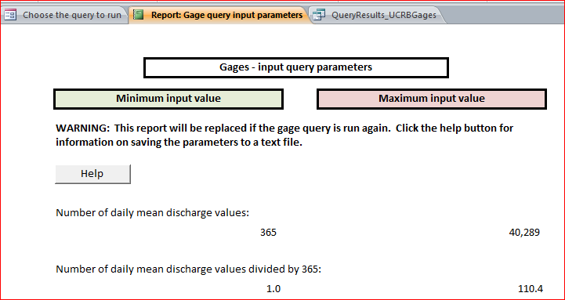

Saving query parameters:
The report containing query parameters will be overwritten each time a new query is run. The report can be exported to plain text or a variety of other formats to save the input parameters for future reference.
To export the report to an external file make sure the report is the "active" tab in the database.

Navigate to the "External Data" tab of the Microsoft Access ribbon and locate the "Export” file options. Click the type of file you wish to export and follow the wizard instructions.
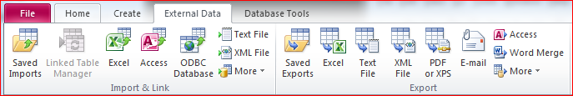

Saving query results:
The query results table will be overwritten if another query is run. The table can be saved to Microsoft Excel or another format as a record of the query or for further manipulation outside the query tool. To save the table, make the “Query Results” tab the active tab in the database and follow the export instructions outlined in the “Saving query parameters” section above.
