Downhole Measurement Lab: Tool Test Report

General Information
Time: 19:00 GMT (Local Time = GMT+5.5 INDIA)
Date of tests: 27 May 2006
Location: Downhole Measurement Lab onboard JOIDES Resolution
Medium used: Ice (Chopped)
Reference: Thermometer
Tests done by: Pieter Pretorius

Notes of interest
The Downhole Measurement Lab pressure core and tools used in this project were non Y2K compliant; thus, dates were set back to 1995. Results should be analyzed with this in mind. The dates were left as is, not to alter the “raw” data.

Applicable “raw” test-result files
These files are located on the NGHP Project Server called “J:\Sysvol\Data1\Physical Properties\DHML\DHML Reports\0 Deg Ice Tests.”

Tools tested
Conducted tests on APCT electronics #10 and #16 with shoe #2 and batteries #1 and #2
Conducted tests on APCM electronics #1 and #7 with housing #5 and battery #1
Conducted tests on DVTP tool with Tip #1
Comparison of APCT-3 and APCT #16

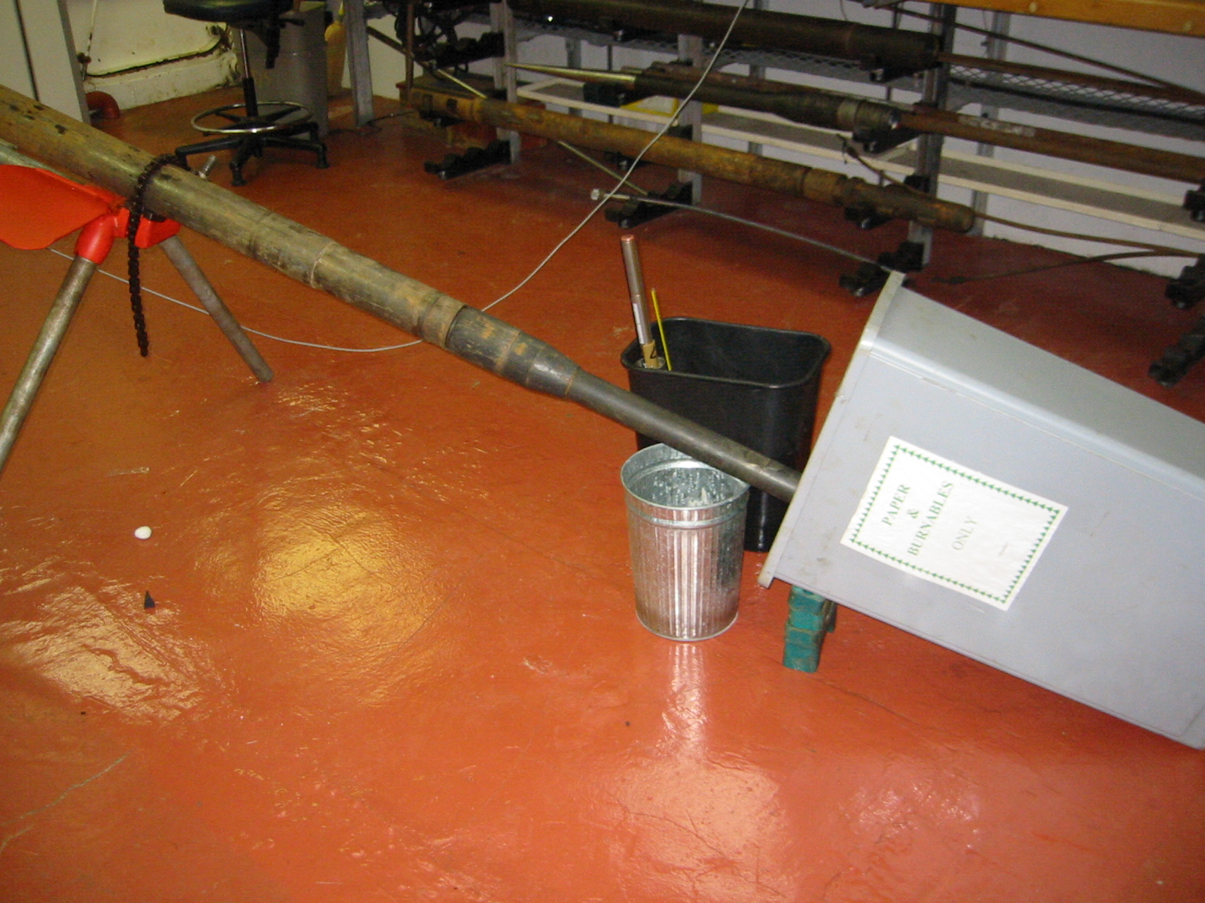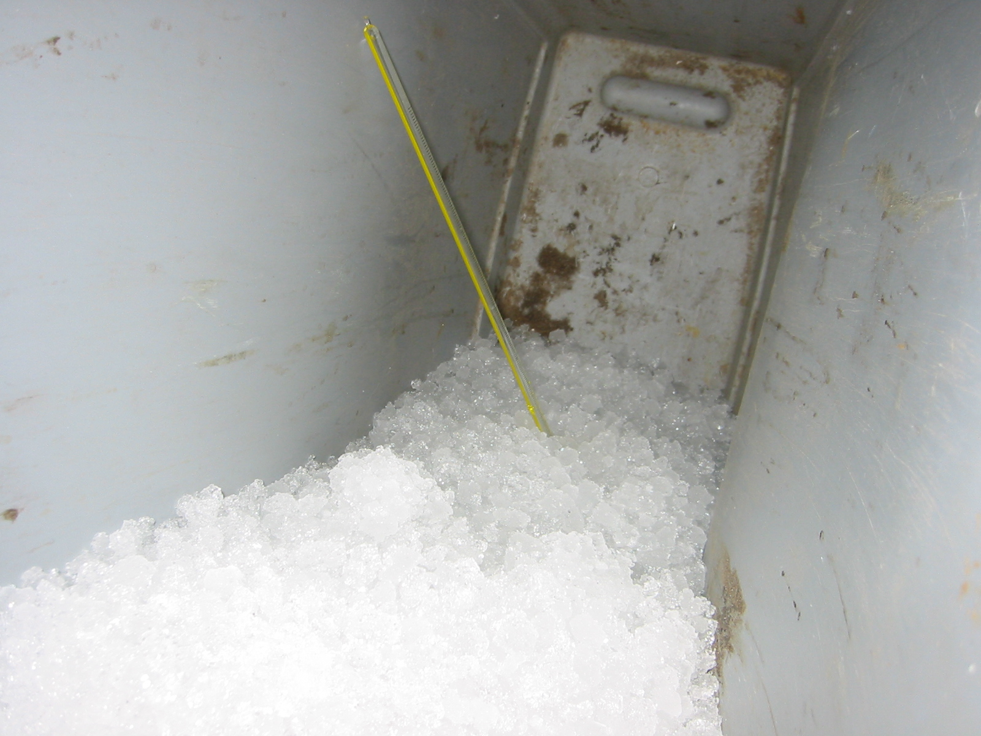

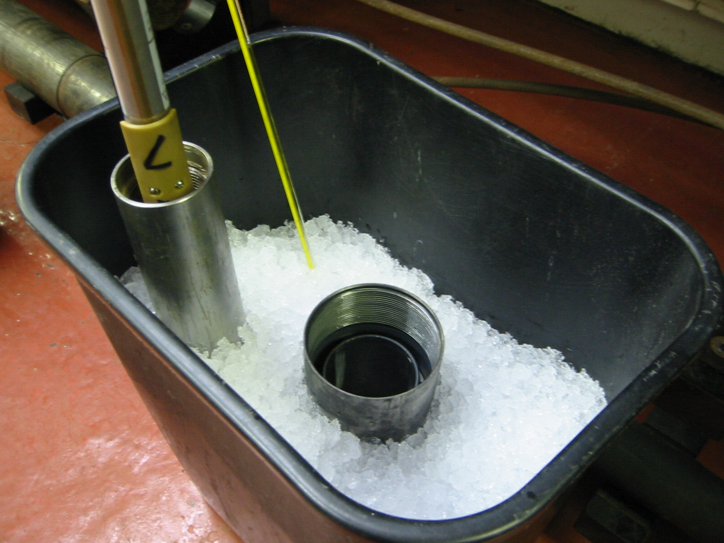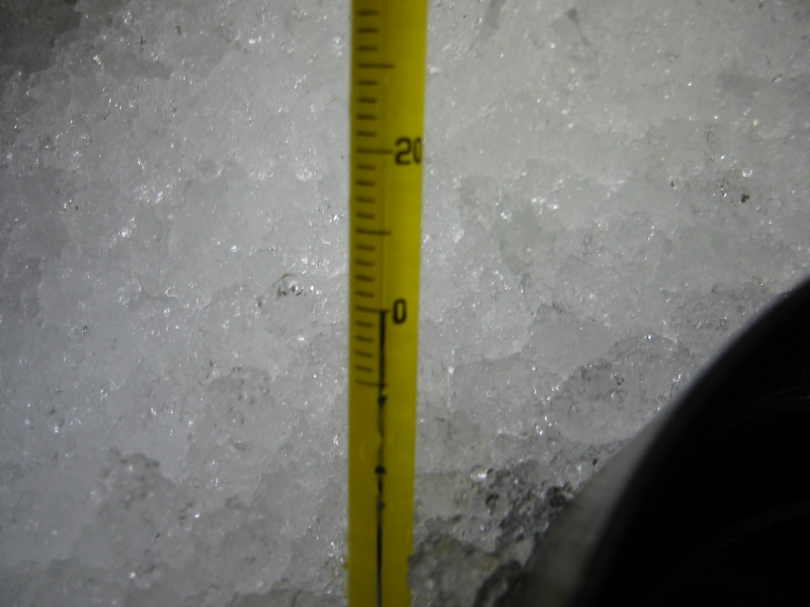
Test Results for APCT # 10
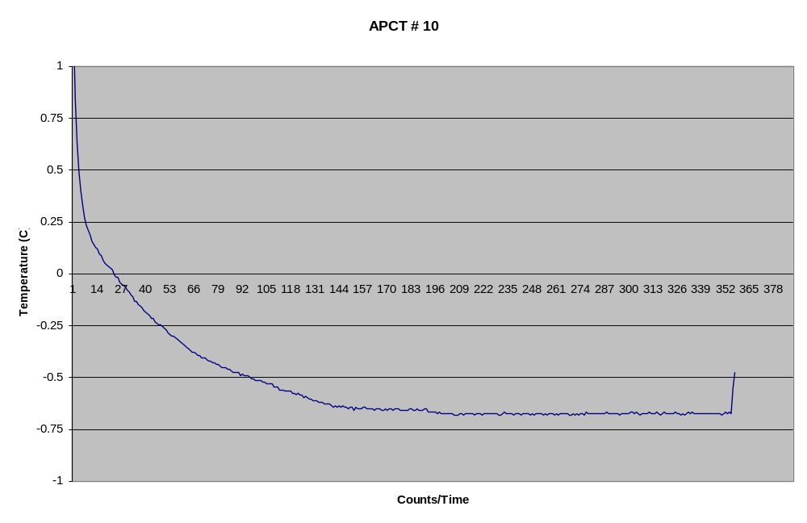

Test Results for APCT # 16
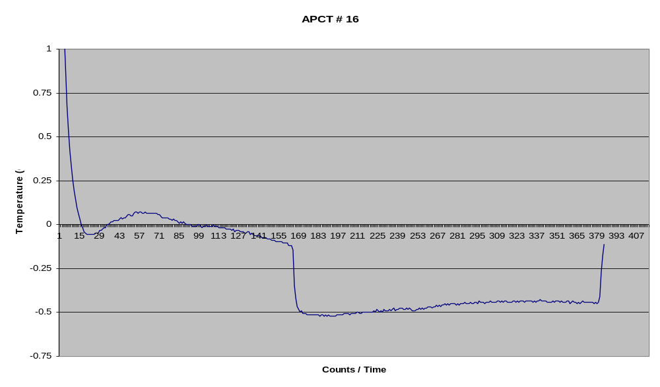
Test Results for APCM # 1
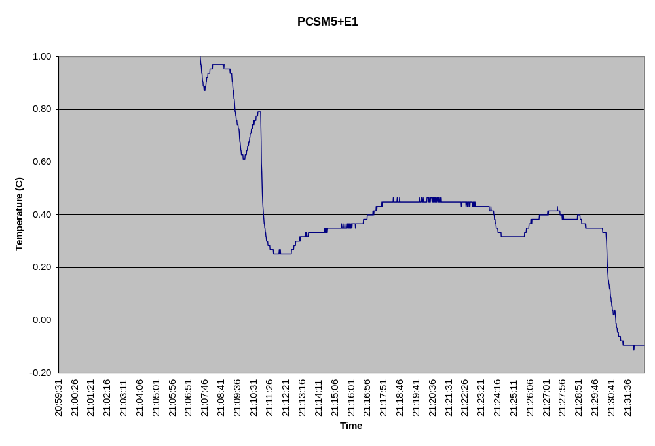

Test Results for APCM # 7
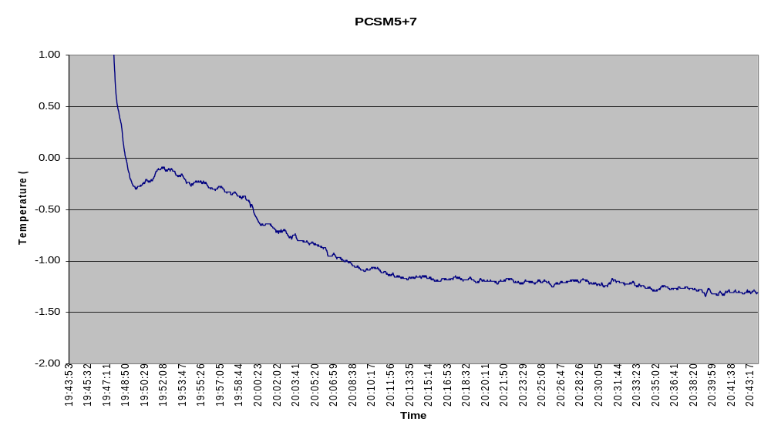
Test Results for DVTP # 1

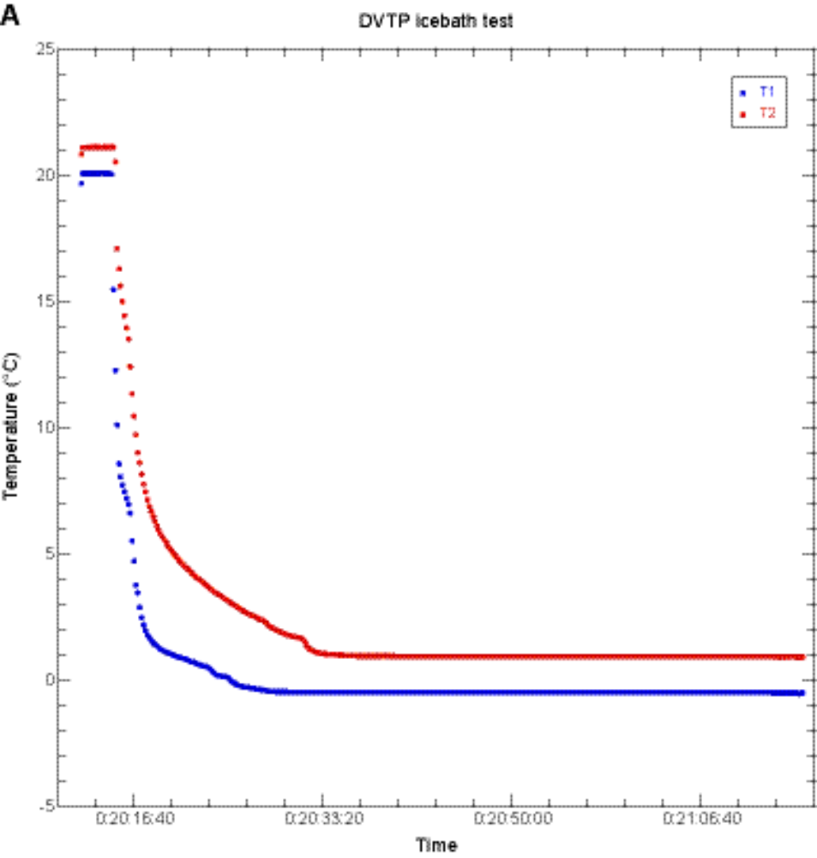

Comparison of APCT-3 and APCT #16



